Year 6 Transition Learning Projects
Individual Qualities
This week’s learning project focuses on your child’s qualities that make them unique and special.
It will give them the opportunity to reflect on what they like, dislike and excel in.
Transition Activities:
Monday- Ask your child to think about what makes them special. What qualities do they possess which they think make them unique? Ask your child to independently write 5 down which they think are the most important. As a parent or family, you should also come up with 5 qualities which you think make your child special. Come together to compare the qualities listed and explain why each person chose the qualities they did. Your child could then write their three best qualities down, explaining why they chose these.
Tuesday- Encourage your child to think about the qualities you discussed yesterday and what each of them mean. Can they create a piece of artwork in the shape of a star to represent their ‘star qualities’? Your child can make the outline of the star using the words chosen or include their qualities within the star itself. Let them be creative in how they want to display their individual qualities.
Wednesday- Art can be a great tool for self-exploration and self-expression. Encourage your child to create a piece of artwork which represents their personality. This could be a picture or something more abstract using materials available at home. Your child may find listening to their favourite music encourages their own expression or being able to complete this in their bedroom if possible. Once completed, ask your child to discuss their artwork with you. What did they want to represent in this piece? How did they try to show off their personality through their artwork?
Thursday- Children have many talents which should be celebrated. Talk to your child about the talents that they have. Together, look at the website for your child’s secondary school and research which extra-curricular clubs are on offer. Can they celebrate their ICT skills at a Coding Club or their problem solving skills at the school Chess Club? If there isn’t a club that suits your child’s capabilities, look at alternative ways your child could practice their skills e.g. local clubs or online learning.
Friday- Every child is unique and special. Using the template below, talk to your child about what makes them them. They can write a paragraph for each heading or draw an illustration in each section. Ask your child to consider: interests, talents, things they would like to be better at and their hopes and aims for secondary school.
Additional Learning Resources Parents May Wish To Engage With:
- This website explains why self confidence is so important and gives some activities on how to build self confidence.
- Premier League Stars have created some helpful videos and activities for self-esteem
- Childline want to help bring out the best in your child through some easy-to-do activities.
- An article for parents which can help with discussions about how to develop self-belief and confidence in children.
#TheLearningProjects

Year 6 Transition Learning Projects
Individual Qualities- Example Work
Below are some examples of how your child could set out their work.
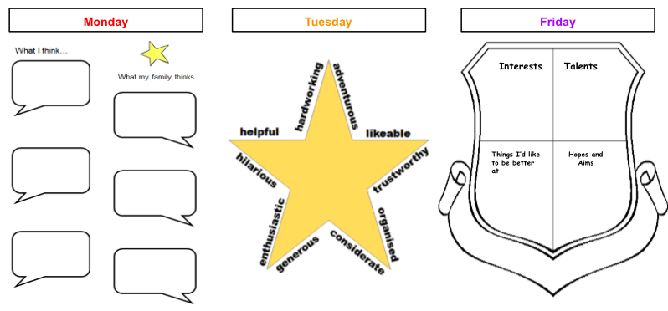

What I think…

What my family think…

