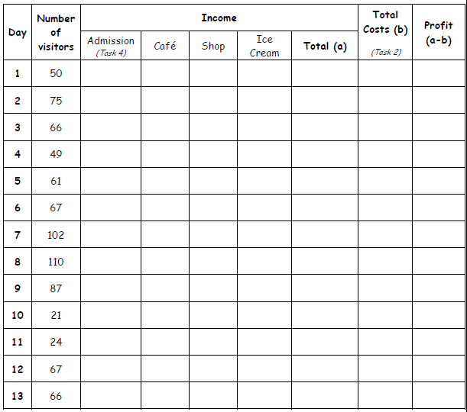

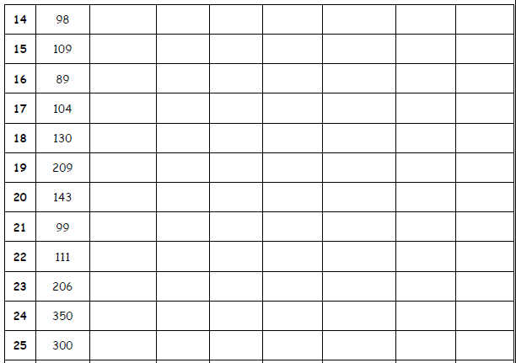

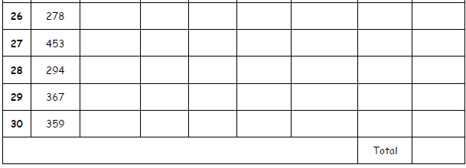

What profit or loss have you made in the first month of opening your theme park?

____________________________________________